Name |  | Company
Tel Number |  | Email
Order Number |  | Date

Please return completed forms to Chiltern Invadex (UK) Limited by email to sales@chilterninvadex.co.uk.

Should you require advice or guidance please call our customer services team on 01869 365500 opt 1.

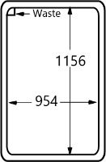
Cubicle Model
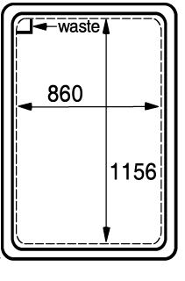
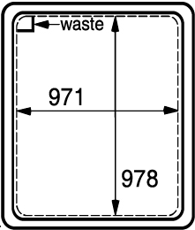
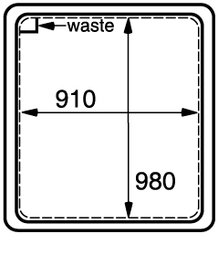
100 101 120 120Plus
Standard Standard Standard Standard

WC WC WC WC

Waste Options Door Options
Gravity Pumped Macerator (additional cost) Bi-fold Pair
(Standard)
Shower Options (additional cost)

None Mira Advance Mira Excel Mixer

Basin Options (WC cubicles only)

Standard plastic basin (filled via shower) Ceramic basin & lever taps (additional cost)

Cubicle Layout
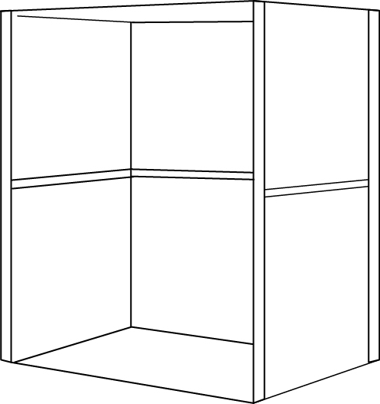
Left  Panel  Right  Panel  Rear  Panel |  | Left Panel | Rear Panel | Right panel
 | Panel height | Full Height | Full Height | Full Height
 |  | Half Height | Half Height | Half Height
 | Shower control position  (full height panel only) | Front of panel  Rear of panel | N/A | Front of panel  Rear of panel
Basin position (as per shower control
unless otherwise requested)
 | WC is located on the rear panel

Light & Fan Options (additional cost)

None Roof light Combined roof light & extractor fan

Seat Options (Standard cubicles only, additional cost)
Maximum seat load 20st (130kg)
Code | Description
SHSS4 | Fold up PVC seat
SHSS4P | Fold up padded seat | Flat Padded Aperture* Horseshoe*
SHSS5 | Fold up PVC seat with arms & backrest
SHSS5P | Fold up padded seat with arms & backrest | Flat Padded Aperture* Horseshoe*
*Where aperture or horseshoe is required select size |  | Small Medium Large
Seat will be positioned on the rear panel, please specify seat height mm

Kit Contents

Standard cubicles are provided with tray, removable ramp, waste, enclosure, doors and 2x horizontal rails

WC cubicles are provided with tray, removable ramp, waste, enclosure, doors, WC pan, high level external cistern, plastic basin,
1 x vertical rail & 1 x horizontal rail

Additional requirements

